Homework July 14, 2021

Write a Python program to calculate the length of a string.  
Example: "Hello"  
Result: 5

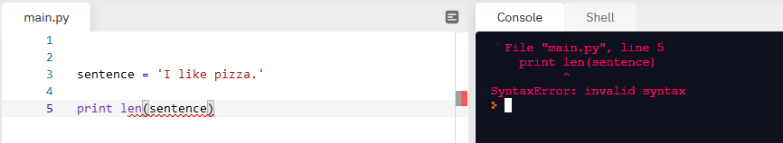

Comments: Not getting this one is preventing me from getting the others. I looked over I think all the videos though and can’t find where it prints the number in the sentence. I remember the example though and remember it being the number 4 I think.

Corrected:

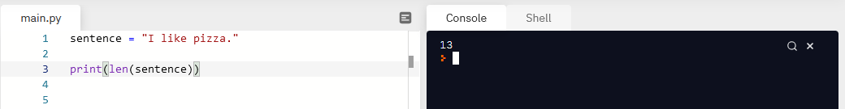

Write a Python program to get a string made of the first 2 and the last 2 chars from a given a string.  
Example: "Python"  
Result: "Pyon"

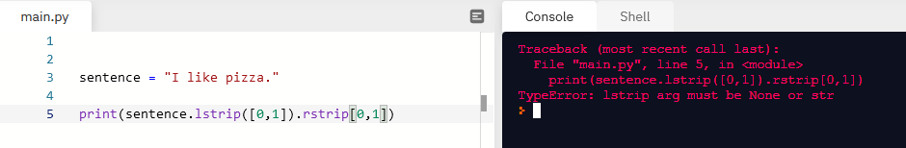

Corrected

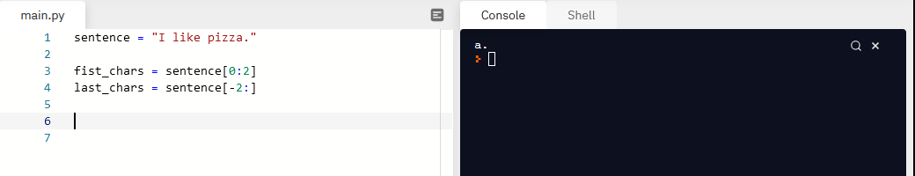

Write a Python program to get a string from a given string where all occurrences of its first char have been changed to '$', except the first char itself.  
Example: "red race car"  
Result: "red $ace ca$"

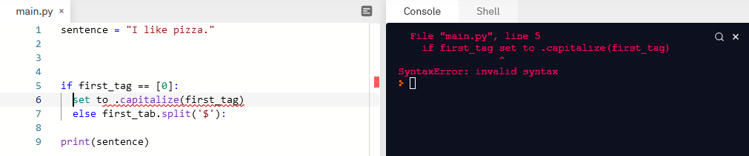

Corrected

